Zid’Avwa Al Bari’i
244107020083 / TI – 2I / 26
All the code here is on GitHub
https://github.com/ZidAvwa/CollegeStudy/tree/main/3rdSemester/11.%20Jobsheet12

Jobsheet 11

Exercise 1

Codes
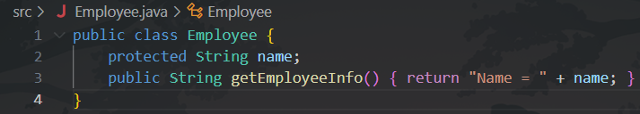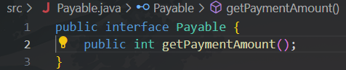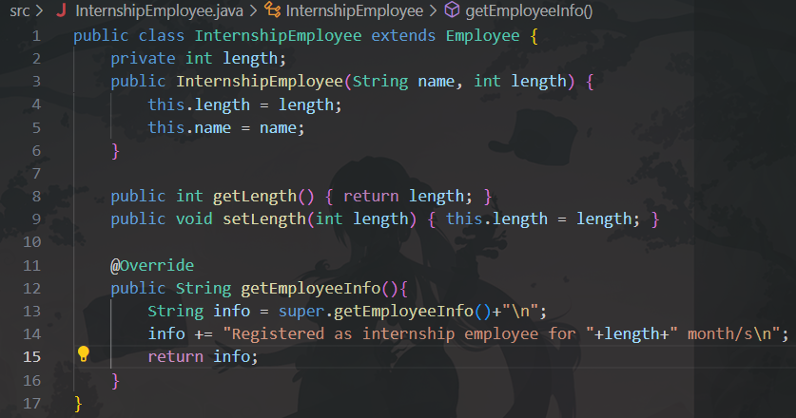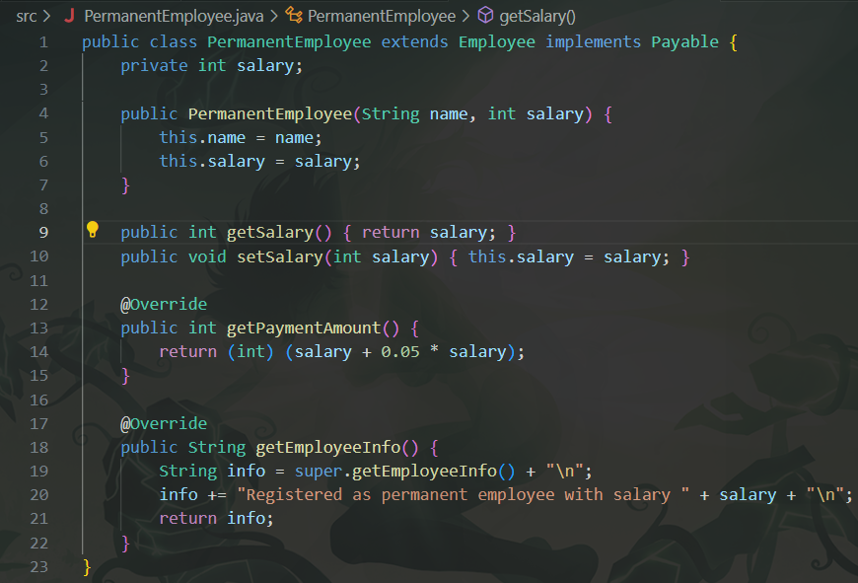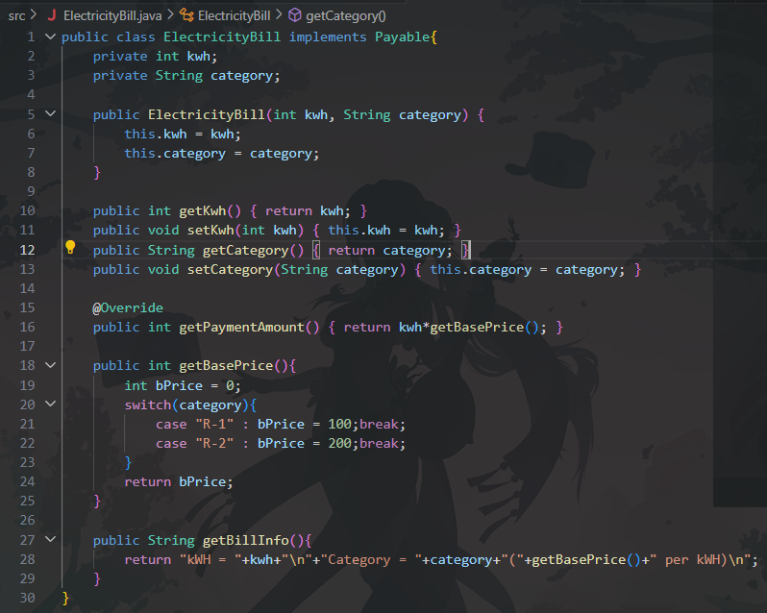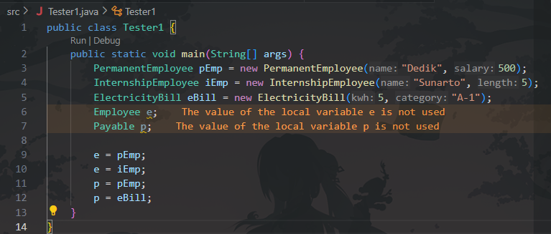

Questions Answers
- What classes are derived from the class Employee?
PermanentEmployee and InternshipEmployee.
- What classes implement the interface Payable?
PermanentEmployee and ElectricityBill.
- Why can e be filled with pEmp and iEmp?
Because both PermanentEmployee (pEmp) and InternshipEmployee (iEmp) are child classes (subclasses) of the Employee class.
- Why can p be filled with pEmp and eBill?
Because both the PermanentEmployee class (pEmp) and the ElectricityBill class (eBill) implement the Payable interface.
- What causes the error for p = iEmp; and e = eBill;?
- p = iEmp; causes an error because the InternshipEmployee class does not implement the Payable interface.
- e = eBill; causes an error because the ElectricityBill class does not extend the Employee class.
- Draw conclusions about the basic concepts/forms of polymorphism! Polymorphism allows a variable of a parent class type (like Employee) to hold objects of its different child classes. It also allows a variable of an interface type (like Payable) to hold objects of any class that implements that interface.

Exercise 2

Code
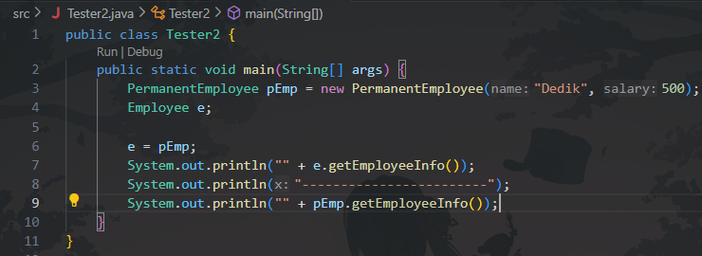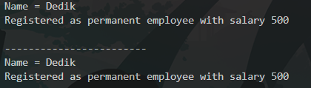

Questions Answers
- Why do e.getEmployeeInfo() and pEmp.getEmployeeInfo() produce the same result?
Because both variables, e and pEmp, are pointing to the exact same object in memory (the PermanentEmployee object created on line 3). Even though e is an Employee type, at runtime, Java calls the overridden getEmployeeInfo() method from the actual object's class, which is PermanentEmployee.
- Why is e.getEmployeeInfo() called a virtual method invocation, but pEmp.getEmployeeInfo() is not?
Because e is a variable of the parent class (Employee). When you call e.getEmployeeInfo(), the Java Virtual Machine (JVM) must check at runtime what kind of object e actually is (in this case, a PermanentEmployee) to know which version of the method to run. This runtime check is the "virtual" invocation.
For pEmp, the variable type is already PermanentEmployee, so the compiler knows exactly which method to call at compile time. There is no runtime check needed.
- So what is meant by virtual method invocation? Why is it called virtual?
It means the specific method that gets executed is determined at runtime based on the actual object's type, not the variable's declared type.
It's called "virtual" because the exact method to be called isn't known at compile time; the decision is deferred until the program is running.

Exercise 3

Code
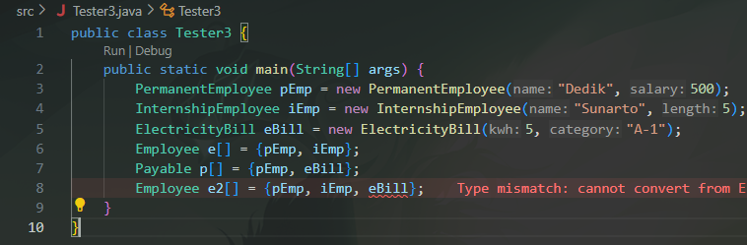

Questions Answers
- Why can the e array be filled with pEmp and iEmp?
Because the array e is of type Employee (Employee[]), and both PermanentEmployee (pEmp) and InternshipEmployee (iEmp) are child classes that extend the Employee class.
- Why can the p array be filled with pEmp and eBill?
Because the array p is of type Payable (Payable[]), and both the PermanentEmployee class (pEmp) and the ElectricityBill class (eBill) implement the Payable interface.
- Why does an error occur on line 8 (Employee e2[] = ...)?
Trying to put an ElectricityBill object (eBill) into an Employee array. The ElectricityBill class does not extend the Employee class, so it's not considered an Employee.

Exercise 4

Code
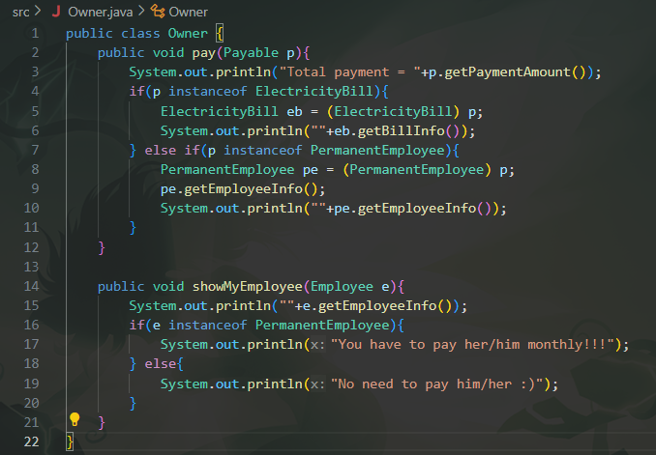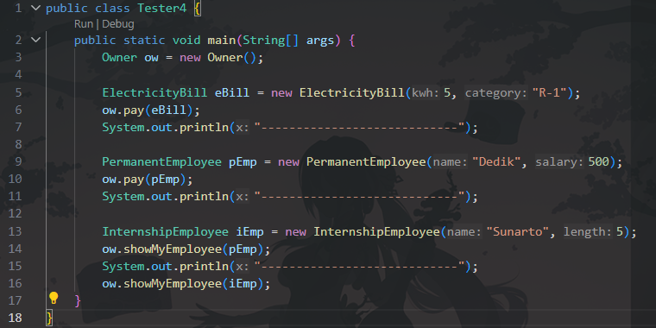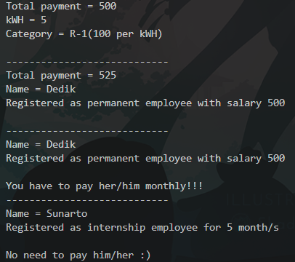

Questions Answers
- Why can ow.pay(eBill) and ow.pay(pEmp) be called?
Because the pay() method requires a Payable argument. Both the ElectricityBill class and the PermanentEmployee class implement the Payable interface, so objects of both classes are valid.
- What is the purpose of making the argument type Payable?
It makes the pay() method flexible. It can accept any object from any class (now or in the future) as long as that class implements the Payable interface.
- Why does ow.pay(iEmp); cause an error?
Because iEmp is an InternshipEmployee object. The InternshipEmployee class does not implement the Payable interface, so it cannot be used as an argument for the pay() method.
- Why is the if(p instanceof ElectricityBill) check needed?
The check is needed to see if the generic Payable object p is specifically an instance of ElectricityBill. This is done so we can safely use methods (like getBillInfo()) that only exist in the ElectricityBill class.
- Why is the cast (ElectricityBill eb = (ElectricityBill) p) necessary?
The cast is necessary to access methods outside of the Payable interface.
The variable p is of type Payable, so you can only call p.getPaymentAmount(). By casting it to (ElectricityBill), Tellng the compiler to treat it as an ElectricityBill object, which allows to call its specific methods, like eb.getBillInfo().

TASK

Code
